CS 255 Business Requirements Document Template

System Components and Design

Purpose
• DriverPass needs a system that helps customers prepare for DMV driving tests through online classes, practice tests, and optional on-the-road training.
• The system will centralize customer accounts, training packages, driving lessons, vehicles, drivers, tests, reports, and activity tracking.
• Authorized users must be able to access business data online from computers or mobile devices; data changes require an online connection to avoid conflicting or duplicate records.

System Background
• DriverPass identified a need for better driver training because many students fail DMV driving tests after relying primarily on previous tests.
• Customers may choose Package One (six hours of in-car training), Package Two (eight hours of in-car training plus an in-person DMV rules/policies lesson), or Package Three (twelve hours of in-car training, the in-person lesson, and online class/practice tests).
• Each driving session is two hours, and the system must track the customer, scheduled driver, lesson time, and assigned car.
• Customers can register through the business by phone and can schedule, cancel, or modify driving appointments online. The secretary can also schedule appointments.
• DriverPass needs a connection to DMV updates for rules, policies, and sample questions, with notifications when updates occur.
• The preferred deployment is web-based and cloud-hosted so backup and security can be handled without requiring DriverPass to manage local infrastructure.

Objectives and Goals
• Provide customers with online access to practice tests and, when included in the selected package, online course content.
• Allow customers and the secretary to create, modify, and cancel two-hour driving-lesson reservations.
• Prevent scheduling conflicts by associating each lesson with the appropriate customer, driver, vehicle, date, and time.
• Provide management with downloadable reports and activity reports identifying who created, canceled, or last modified reservations and records.
• Provide role-based access for the owner, IT officer, secretary, and customers.
• Allow the IT officer to reset passwords, block employee access, and maintain user accounts.
• Allow management to disable a package without requiring a new software release; adding/removing modules remains a future development task.

Requirements

Nonfunctional Requirements
• Performance requirements: The system shall be web-based and accessible from computers and mobile devices. Normal account, reservation, and test operations should respond promptly enough for routine business use.
• Performance requirements: The system shall support concurrent customer and staff use through a centralized service.
• Platform constraints: The preferred platform is a cloud-hosted web application with a centralized database.
• Platform constraints: Data modifications shall require an online connection; offline use is limited to accessing information already made available for viewing or download.
• Accuracy and precision: The system shall uniquely identify users and enforce role-based permissions.
• Accuracy and precision: Reservation records shall accurately associate a customer with a date/time, driver, and vehicle, and driving sessions shall be represented as two hours.
• Accuracy and precision: The system shall retain activity information identifying who created, canceled, or last modified relevant records.
• Adaptability: Administrators shall be able to add, modify, disable, or remove user access without changing application code.
• Adaptability: The system shall allow DriverPass to disable a package so new customers cannot register for it, while future package/module changes can be handled by developers.
• Adaptability: The IT officer shall have the administrative access needed to maintain accounts and system access.
• Security: The system shall require authenticated accounts and role-based authorization.
• Security: Customer and payment information shall be protected during transmission and storage using appropriate security controls.
• Security: Repeated failed authentication attempts should be monitored and protected against brute-force attempts through appropriate account controls.
• Security: Users who forget passwords shall have an automated reset process, and the IT officer shall be able to block employee access.

Functional Requirements
• The system shall create and maintain customer accounts containing first name, last name, address, phone number, state, and registration/payment information.
• The system shall record the customer's pickup location and use the same location as the drop-off location.
• The system shall support the three DriverPass training packages and their stated training components.
• The system shall allow an authorized administrator to disable a package so new customers cannot register for it.
• The system shall allow customers to schedule driving lessons online.
• The system shall allow customers to cancel and modify eligible driving appointments online.
• The system shall allow the secretary to create and manage appointments for customers who call or visit the office.
• The system shall schedule each driving session for two hours.
• The system shall associate each driving lesson with a customer, driver, vehicle, date, start time, and end time.
• The system shall maintain information for DriverPass's drivers and ten vehicles so assignments can be tracked.
• The system shall provide online classes and practice tests when the customer's package includes those resources.
• The system shall record test name, time taken, score, and status, including not taken, in progress, failed, and passed.
• The system shall store driver comments and lesson start/end times for later review.
• The system shall receive DMV-related updates for rules, policies, and sample questions and notify DriverPass when updates are available.
• The system shall allow authorized users to generate and download reports for use outside the system, including information that can be worked with in Excel.
• The system shall maintain an activity trail identifying who created, canceled, or last modified relevant records.
• The system shall allow the IT officer to reset passwords and block employee access.
• The system shall provide a page for contacting DriverPass and a means for DriverPass to contact students.

User Interface
• Customer interface: A responsive web interface accessible from a computer or mobile device for account access, package information, online classes/practice tests, appointment scheduling, cancellation/modification, and contact options.
• Secretary interface: A staff-facing web interface for entering customer information and creating, modifying, and canceling appointments on behalf of customers.
• Owner/management interface: A dashboard/reporting interface for reviewing reservations, driver notes, test progress, activity records, and downloadable reports.
• IT officer interface: An administrative interface for user-account management, password resets, access blocking, roles, and permissions.
• Test interface: A clear progress view showing test name, time taken, score, and status.
• Lesson/driver interface: A view showing lesson time, start hour, end hour, driver, and driver comments.

Assumptions
• DriverPass will have reliable internet connectivity for system updates and all data modifications.
• Customers will have access to a supported web browser on a computer or mobile device.
• DriverPass will provide accurate driver, vehicle, package, and scheduling information.
• The DMV will provide a usable mechanism through which DriverPass can receive rules, policies, and sample-question updates; the interview does not specify the technical integration method.
• Payment-card information will be handled using an appropriate secure payment/data-storage approach; the interview specifies information to collect but not a payment processor.
• Adding or removing complete software modules will remain a developer/system-analyst responsibility for future releases.

Limitations
• The current release does not need a nondeveloper interface for adding/removing software modules; that is a future consideration.
• The interview does not specify a cloud provider, database technology, programming language, browser support matrix, or exact performance thresholds.
• The system depends on an internet connection for creating or modifying records and is not designed for full offline transactional operation.
• The development schedule is constrained by the dates established in the interview planning discussion.
• DMV integration details are not defined in the interview, so the final technical design may depend on the interface or update mechanism made available by the DMV.

Gantt Chart
The schedule below follows the dates and dependencies established by Sam and Jennifer in the project-planning portion of the interview.
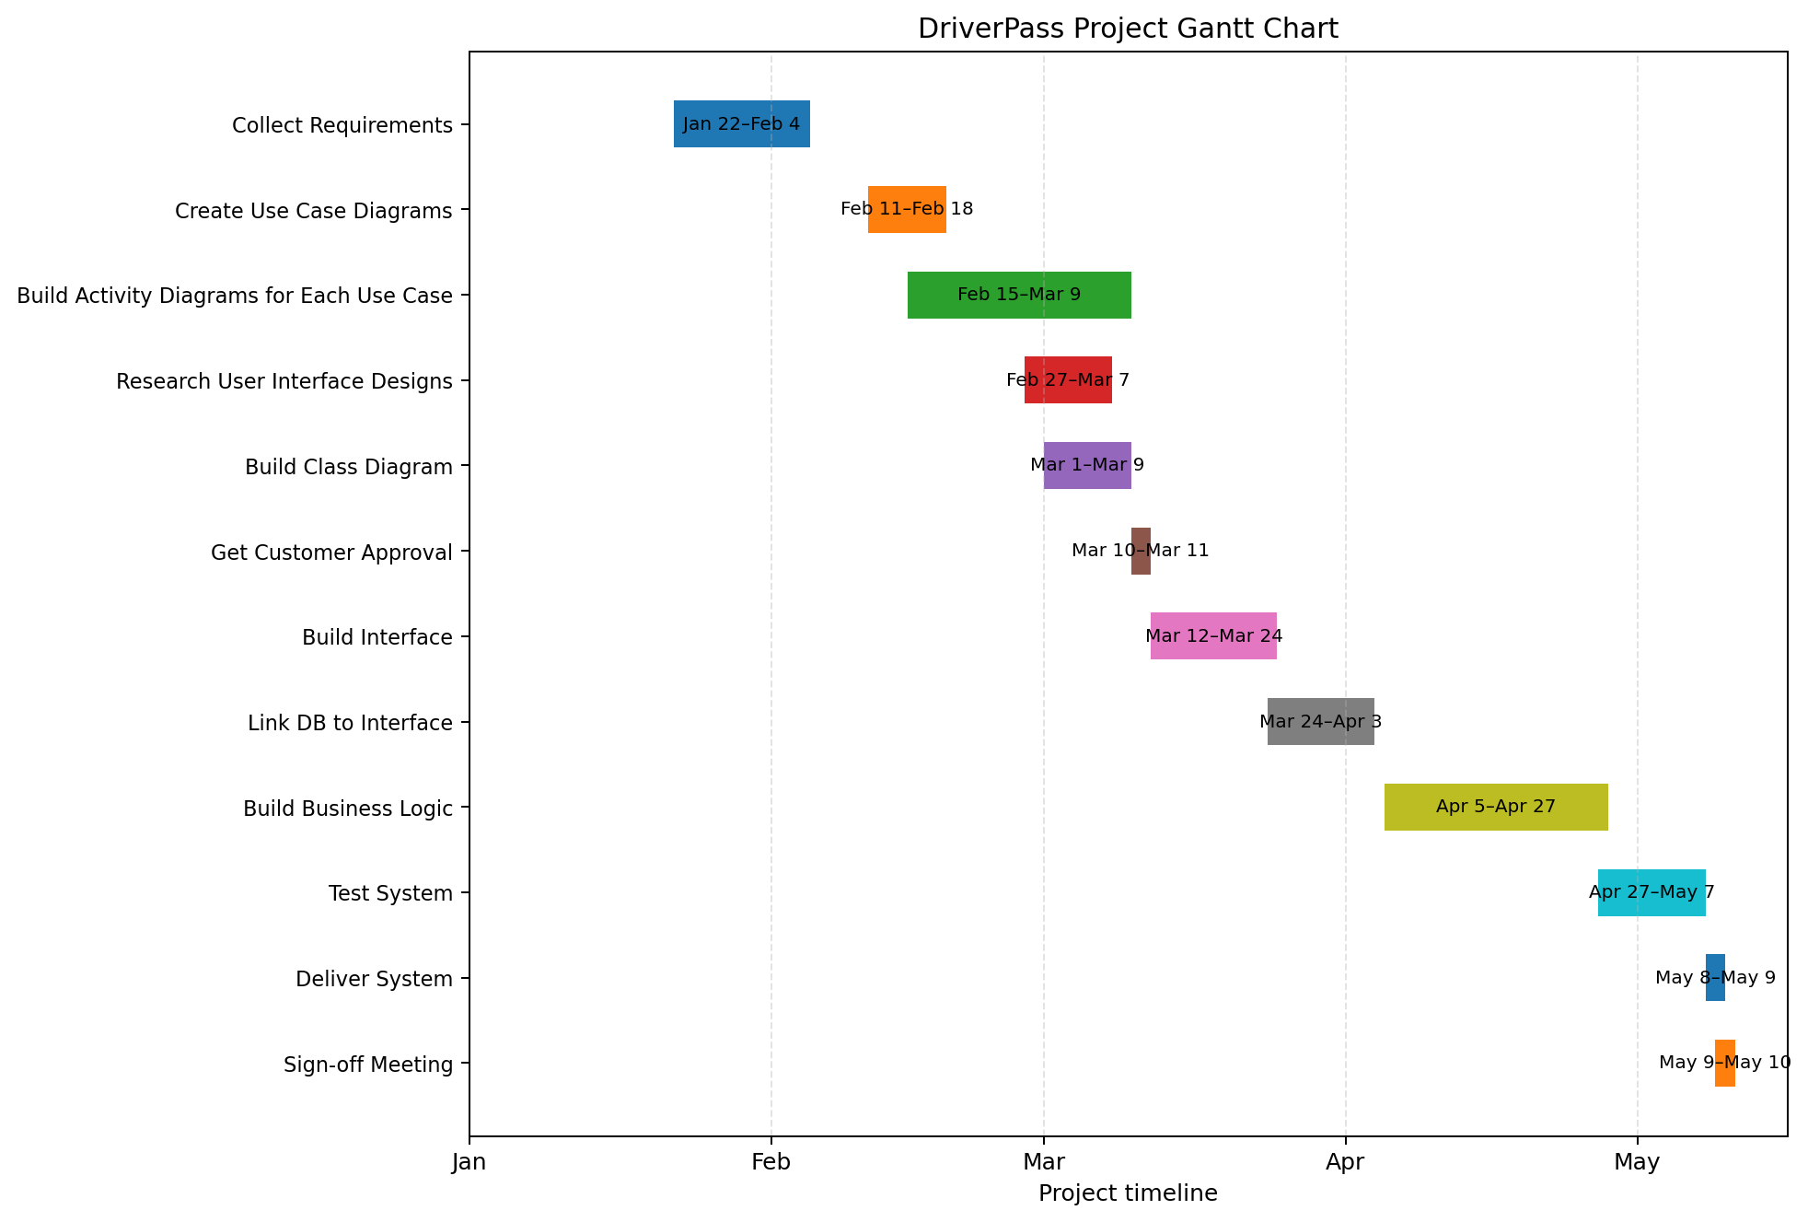
Figure 1. DriverPass project schedule based on the interview transcript.
Source note: Requirements and schedule are based on the CS 255 DriverPass Interview Transcript.

